

**Expanded Functions**

**EFDA**

**A Continuing**

**Education**

**Course for Dental Professionals**

Amalgam and Resin Restorative Techniques

Dr. Annette Williamson

Program Director

219.663.4200

219.663.4700 fax



**Registration Form**

***Applicant Information:***

**Name: Address: City: State: Zip: Home #: Cell #: E-mail Address:**

***Employer Information:***

**Employer: Office Address: City: State: Zip:**

**Office Phone:**

***EFDA Tuition:* $1400.00**

Check Money Order Cash

***Qualifications:*** Select all that apply

Certified Dental Assistant (CDA)

DA with at least 2 years’ experience

Vocational Dental Program

Board Certified Dental Hygienist

**Must Provide Proof with Registration Form**

***Participant’s Signature:***

**By submitting this registration, I affirm that I have read and agreed to the cancellation policy, terms of enrollment, attendance policies and course credit.**

***Doctor’s Signature:***

**This signature certifies that the registered participant named above is a currently employed dental assistant.**

**Date: Hire Date:**

**Annette J. Williamson, DDS**

Dr. Annette Williamson has been in private practice in Crown Point, Indiana since 1987. A graduate of Indiana University School of Dentistry, she received her Bachelor of Science in Biology at Purdue University.

She is an officer of the Northwest Indiana Dental Society and former instructor at Indiana University Northwest Campus in Microbiology/Infection Control and Radiology.

Dr. Williamson is a member of the American Dental Association, Indiana Dental Association, Northwest Indiana Dental Society, Chicago Dental Society and holds Fellowships in the Academy of General Dentistry, American College of Dentists, and the Pierre Fauchard Academy. In 2016 she was appointed to the State Board of Dentistry by the Governor of Indiana.

.



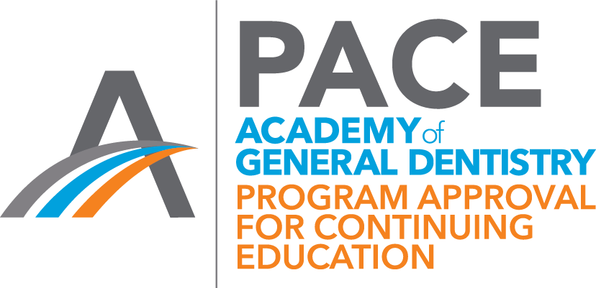

*Disclosure Statement:*

*In accordance with the ADA CERP Standards for Commercial or Promotional Conflict of Interest, educational programs sponsored by Annette Williamson DDS PC must demonstrate balance, independence, objectivity, and scientific rigor. Speakers are required to disclose any relevant financial interest or other relationship with the manufacturers of any commercial product(s) and/or provider(s) of commercial services that are discussed in an educational activity. No conflicts to declare. Sponsorship of a continuing education program by Annette Williamson DDS PC does not necessarily imply endorsement of a particular philosophy, procedure, or product.*

Annette Williamson DDS PC is designated as an Approved PACE Program Provider by the Academy of General Dentistry. The formal continuing education programs of this program provider are accepted by the AGD for Fellowship/Mastership and membership maintenance credit. Approval does not imply acceptance by a state or provincial board of dentistry or AGD endorsement. The current term of approval extends 07/01/2018 to 06/30/2022. Provider ID # 370157

Annette Williamson DDS, PC is an ADA CERP Recognized Provider

ADA CERP is a service of the American Dental Association to assist dental professionals in identifying quality providers of continuing dental education. ADA CERP does not approve or endorse individual courses or instructors, nor does it imply acceptance of credit hours by boards of dentistry.

Annette Williamson DDS, PC designates this course is for 44 hours CE.



**Expanded Functions for Dental Auxiliaries**

**Course Location:**

Annette Williamson, DDS 11043 Broadway, Suite A Crown Point, IN 46307 **219.663.4200**

dr[annette@awdds.com](mailto:annette@awdds.com)

**Enrollment Requirements:**

This course is open to all auxiliary with one of the following qualifications:

* Certified Dental Assistant degree (CDA)
* DA with at least 2 years’ experience
* Completed a vocational Dental Program
* Board Certified Dental Hygienist

Please provide verification of your level of experience. Each participant must be currently employed at a dental office. Enrollment is limited; your paid tuition reserves your place in this program. Registration is processed in the order it is received.

**Tuition: $1400.00 per participant**

Tuition includes: textbook, lab supplies, equipment, restorative materials and ivorine teeth. Participants are required to provide a 3-ring binder. **Application and proof of eligibility must accompany your tuition payment.** Please make all checks payable to: **Dr. Annette Williamson**. Tuition must be received no later than two weeks prior to the beginning of class. Only **payment in full** will guarantee your position in the class.



**Refund Statement:**

Course materials must be ordered in advance; therefore refunds will not be given once applications/payments have been received.

**Course Format:**

* Lecture
* Demonstration
* Laboratory manikin experience
* Video presentation
* Clinical dental office experience

(See *Employer Responsibility below)

**Course Description:**

This course will provide dental auxiliaries with knowledge in the areas of: amalgam and resin restorative techniques, including preventative pit and fissure sealants. An orientation packet will be provided prior to the initial session for study purposes. A written preliminary entrance examination will be given to each student to ensure a basic knowledge of dental anatomy. Failure to pass this preliminary examination will result in a withdrawal from the course. A

$400.00 fee will be assessed to cover non-recoupable costs. The remaining balance will be credited towards the next offered Expanded Functions course.

**\*Employer Responsibility:**

Each student must demonstrate competency by placing restorations between instructional sessions while under the *supervising direction* of their employer/dentist.



**Course Dates: 2021**

Orientation: March 3rd, 5:30 to 7:30pm

Class Sessions: 8:00 am to 4:00 pm

* March 6th
* March 13th
* March 20th
* March 27th
* April 3rd
* April 10th

**Course Objectives:**

* Didactic/pre-clinical training in amalgam & resin restorations
* Pre-clinical & written examinations to demonstrate understanding & competency
* Demonstrate placement of rubber dam with isolation techniques
* The placement, carving & finishing of amalgam & resin restorations in an environment that is compliant with OSHA regulations
* Utilize knowledge of oral anatomy & application to restorative dentistry
* Review of Dental Law with the emphasis on procedures delegated to the competent dental auxiliary

**Course Credit:**

An EFDA certificate of completion will be awarded to those students who successfully pass all proficiency exams and attendance requirements. Attendance is mandatory for all sessions. Make-up sessions will NOT be offered.